**Project overview**

Crystal Products is a polished, static e‑commerce UI built to showcase a luxury crystal brand with a cohesive “Celestial Luxury” identity. The site demonstrates advanced visual design (Glassmorphism 3.0), refined layout techniques, and micro‑interactions to simulate a premium product browsing experience without a backend.

Pages (what each page is and what it showcases)

**Home (index.html)**

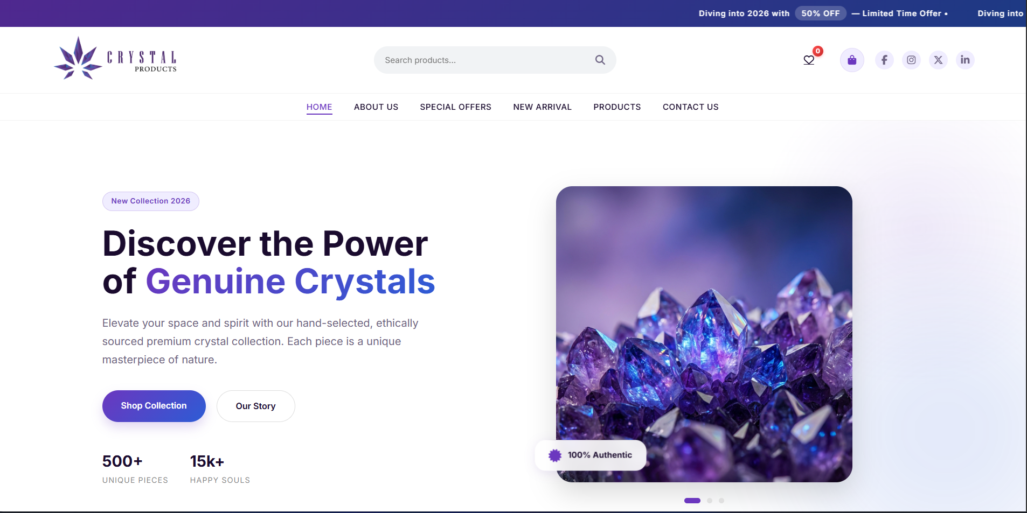

Purpose: Brand introduction and conversion-focused landing.

Key content: Split-layout hero (large typographic callout + floating visual), featured/bestseller grid, short brand story, prominent CTAs.

Visual emphasis: Asymmetrical hero, levitating product visuals, layered frosted cards.

**Products (products.html)**

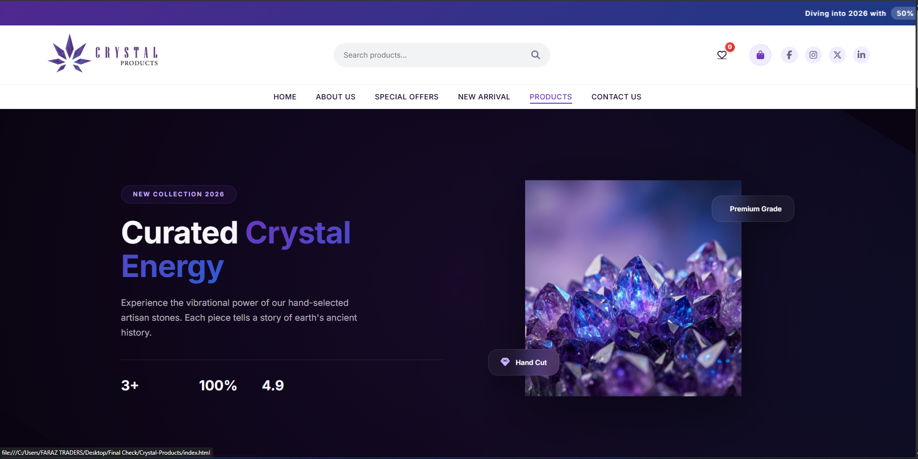

Purpose: Full product catalog and browsing.

Key content: Grid/list of product cards with images, titles, price, subtle hover states and quick micro-interactions.

Visual emphasis: Glass product cards with soft borders and depth; product-focused composition to simulate a premium catalog.

**New Arrivals (new-arrival.html)**

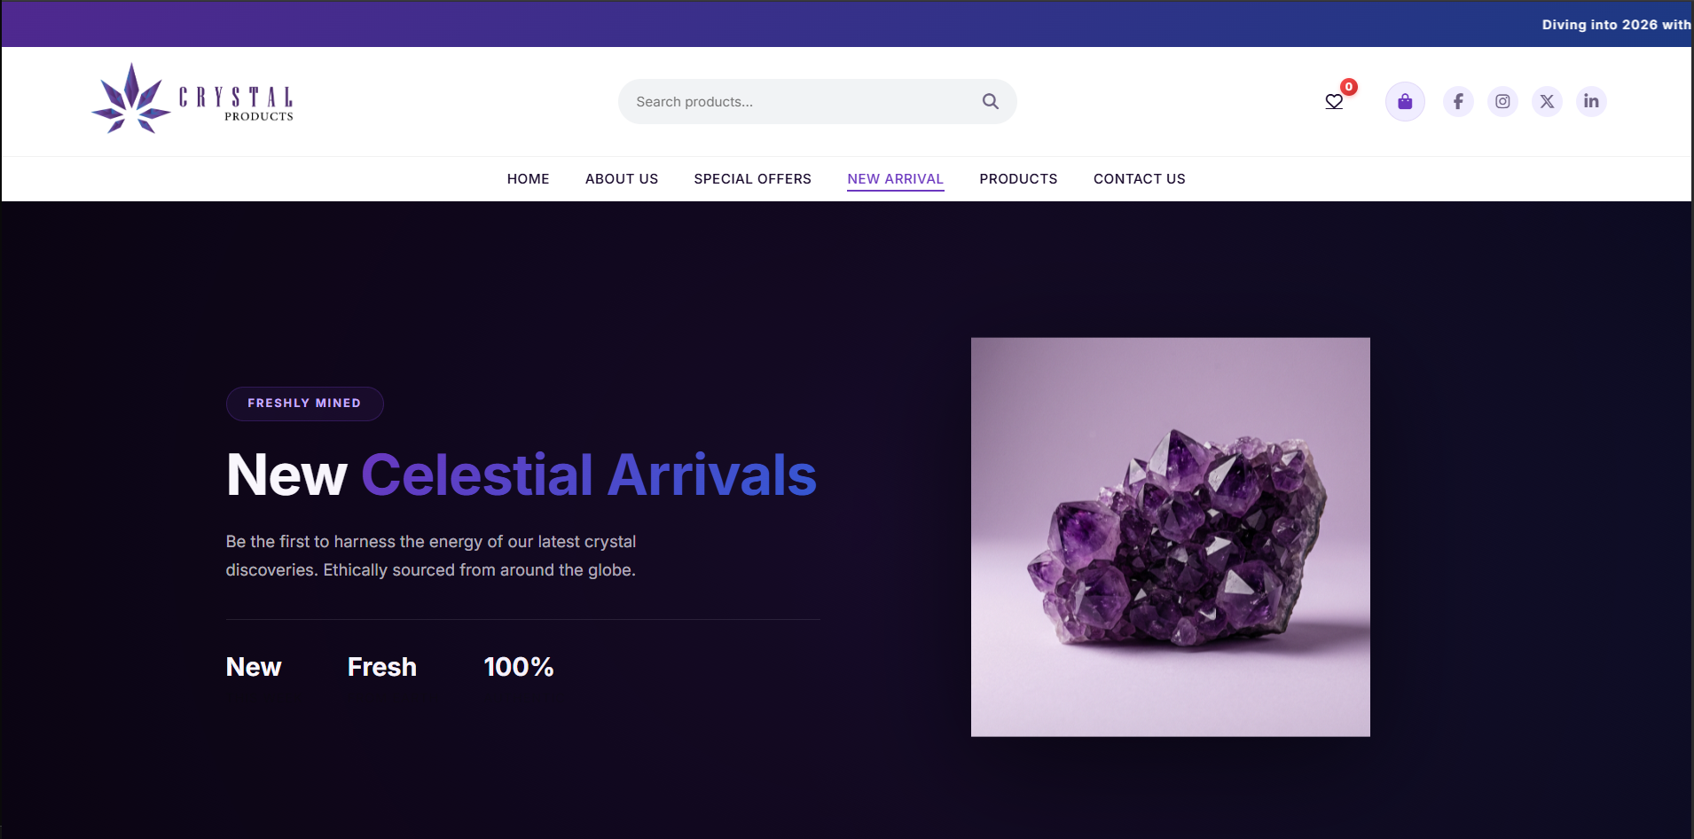

Purpose: Spotlight latest releases.

Key content: Curated product highlights, hero treatment tuned toward “new” messaging, visually prominent feature cards.

Visual emphasis: Emphasis on motion and staggered entry to draw attention to new items.

**Offers (offers.html)**

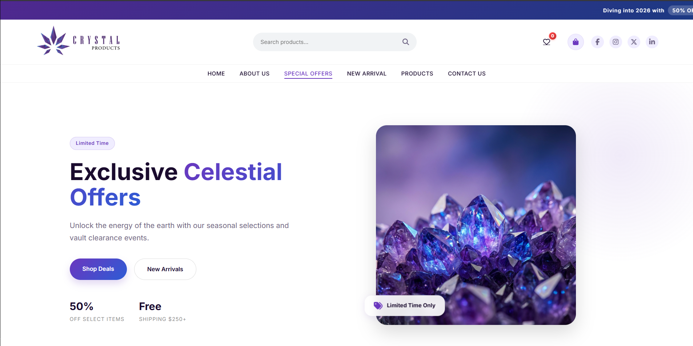

Purpose: Promotions, seasonal deals and limited offers.

Key content: Promotional banners or cards, special pricing callouts, urgency/CTA elements.

Visual emphasis: Elevated contrast and motion to highlight limited-time content.

**About (about.html)**

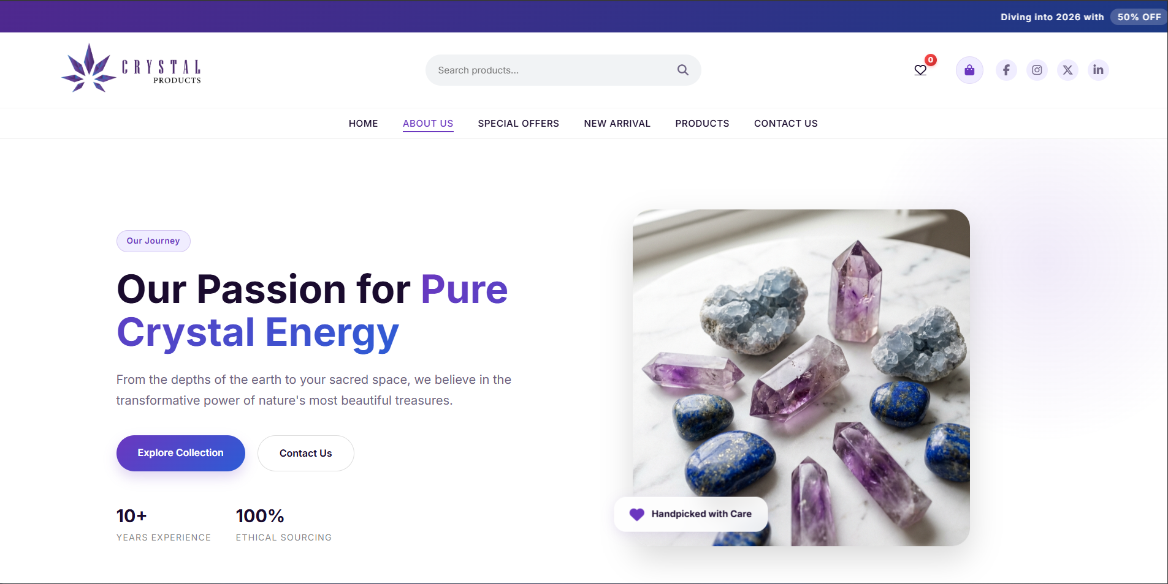

Purpose: Brand story and heritage.

Key content: Narrative sections about craft, materials, inspiration; supporting imagery.

Visual emphasis: Elegant typography, restrained layout to communicate heritage and quality.

**Contact (contact.html)**

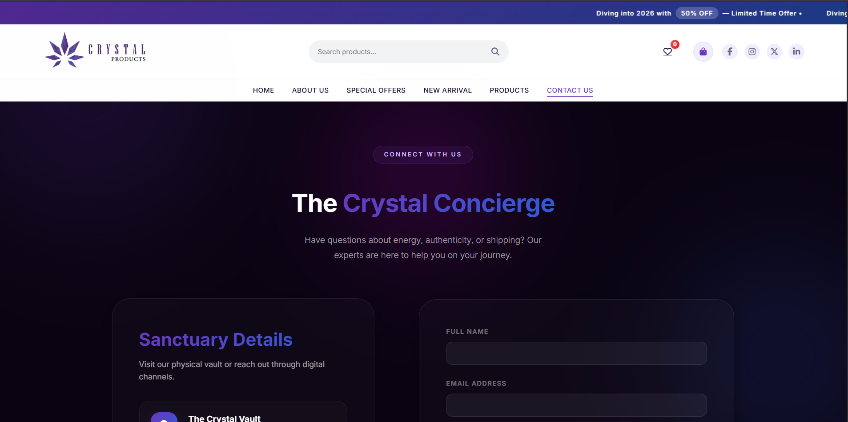

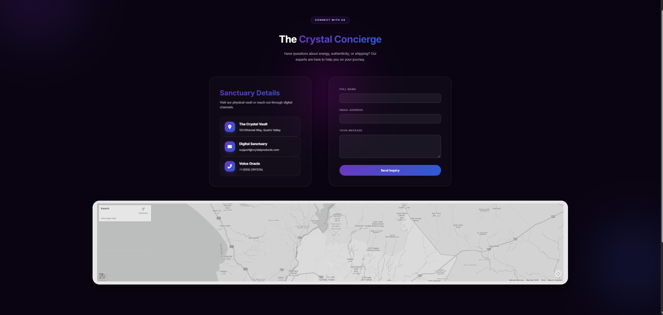

Purpose: Customer contact and inquiries.

Key content: Clean contact form layout presented inside glass-grid panels, simple fields and CTA to submit.

Visual emphasis: Minimal, uncluttered layout with frosted glass panels to maintain the brand aesthetic.

**Core UI features (visible across the site)**

**Dark Luxury Theme**

Deep purple/black base palette that conveys premium, moody atmosphere.

Consistent color and typographic rhythm across pages.

**Glassmorphism 3.0**

Frosted, translucent panels with subtle borders, inner glows and layered blur.

Used for navigation, product cards, overlays and form panels to create depth and hierarchy.

**Split-layout Hero Sections**

Asymmetrical hero components combining bold typography with floating/levitating product graphics to create modern, cinematic entries.

**Product Cards**

Glass-styled cards containing image, title, price and hover animations.

Micro-interactions reveal affordances (e.g., CTA highlight, subtle scale/translate on hover).

Responsive Navigation

Glass-effect navigation bar shared across pages.

Mobile-friendly toggle / collapsing behavior with synchronized styling and animations.

Motion and micro-interactions

Floating/levitation animations (floatY) applied to imagery to imply lightness.

Staggered entry animations for lists/grids so items appear sequentially and feel more dynamic.

Smooth hover transitions for buttons and product cards (scale, shadow, glow).

Scroll-triggered effects for parallax-like depth and entrance animations.

**Design system & typography**

Single visual system applied across pages: consistent spacing, component sizing, and typography (Inter).

Reusable components (cards, CTA buttons, hero blocks) exhibiting consistent states (default, hover, focus).

User experience highlights (what users perceive)

Premium, consistent look and feel that frames products as luxury items.

Clear visual hierarchy: hero → featured products → brand story → CTAs.

Interaction cues (hover, motion) improve perceived polish and usability.

**Technical surface (short)**

Static front-end built with semantic HTML, a central CSS file driving tokens/animations and lightweight vanilla JavaScript for navigation, sliders and scroll effects.

No backend required—ideal for a live demo via GitHub Pages or local static preview.

**Concise elevator pitch:**

Crystal Products is a curated, high-fidelity front-end prototype that demonstrates a premium e‑commerce UI using advanced glassmorphism, purposeful motion, and a unified design system—designed to showcase UX, visual design skills, and front-end implementation for a CPISM portfolio project.